Elton, Gruber, Brown, and Goetzmann
Modern Portfolio Theory and Investment Analysis, 9th Edition
Solutions to Text Problems: Chapter 9

Chapter 9: Problem 1
In the table below, given that the riskless rate equals 5%, the securities are ranked in descending order by their excess return over beta.

Security Rank i 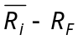 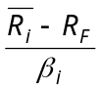 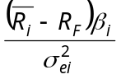 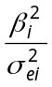 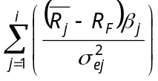 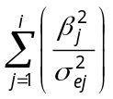 C_{i}
1 | 1 | 10 | 10.0000 | 0.3333 | 0.0333 | 0.3333 | 0.0333 | 2.5000
6 | 2 | 9 | 6.0000 | 1.3500 | 0.2250 | 1.6833 | 0.2583 | 4.6980
2 | 3 | 7 | 4.6667 | 0.5250 | 0.1125 | 2.2083 | 0.3708 | 4.6910
5 | 4 | 4 | 4.0000 | 0.2000 | 0.0500 | 2.4083 | 0.4208 | 4.6242
4 | 5 | 3 | 3.7500 | 0.2400 | 0.0640 | 2.6483 | 0.4848 | 4.5286
3 | 6 | 6 | 3.0000 | 0.3000 | 0.1000 | 2.9483 | 0.5848 | 4.3053

The numbers in the column above labeled C_{i} were obtained by recalling from the text that, if the Sharpe single-index model holds:

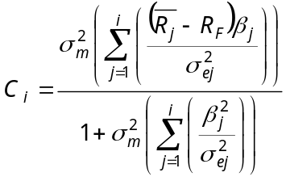
Thus, given that 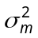 = 10:
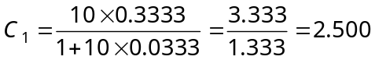

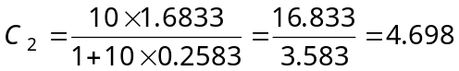
etc.

With no short sales, we only include those securities for which 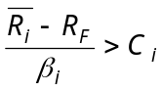. Thus, only securities 1 and 6 (the highest and second highest ranked securities in the above table) are in the optimal (tangent) portfolio. We could have stopped our calculations after the first time we found a ranked security for which 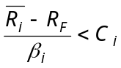, (in this case the third highest ranked security, security 2), but we did not so that we could demonstrate that for all of the remaining lower ranked securities as well.

Since security 6 (the second highest ranked security, where i = 2) is the last ranked security in descending order for which , we set C* = C₂ = 4.698 and solve for the optimum portfolio’s weights using the following formulas:

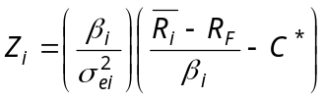

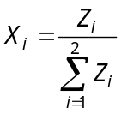
This gives us:

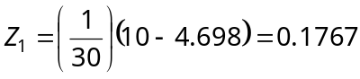

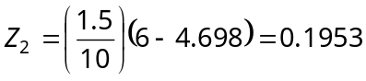

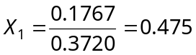

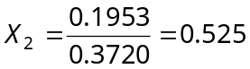

Since i = 1 for security 1 and i = 2 for security 6, the optimum (tangent) portfolio when short sales are not allowed consists of 47.5% invested in security 1 and 52.5% invested in security 6.

Chapter 9: Problem 2

This problem uses the same input data as Problem 1. When short sales are allowed, all securities are included and C* is equal to the value of C_{i} for the lowest ranked security. Referring back to the table given in the answer to Problem 1, we see that the lowest ranked security is security 3, where i = 6. Therefore, we have C* = C₆ = 4.3053.

To solve for the optimum portfolio’s weights, we use the following formulas:

and
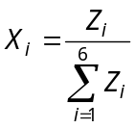 (for the standard definition of short sales)
or
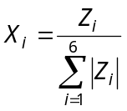 (for the Lintner definition of short sales)

So we have:

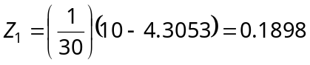

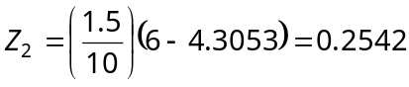

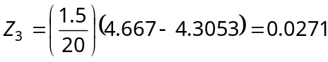

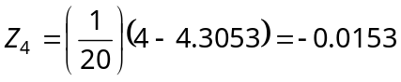

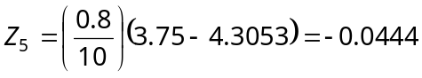

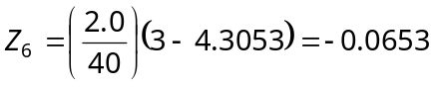

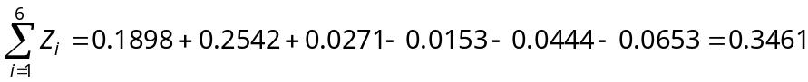

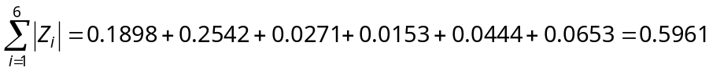

This gives us the following weights (by rank order) for the optimum portfolios under either the standard definition of short sales or the Lintner definition of short sales:

Standard Definition Lintner Definition

Security 1 (i = 1) 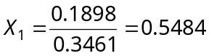 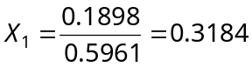

Security 6 (i = 2) 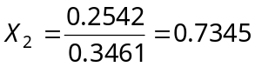 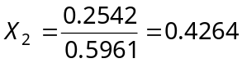

Security 2 (i = 3) 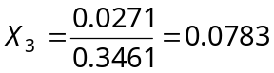 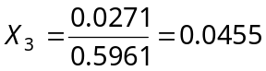

Security 5 (i = 4) 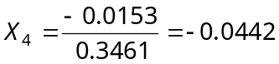 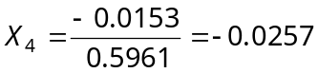

Security 4 (i = 5) 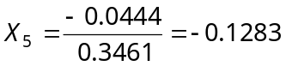 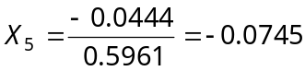

Security 3 (i = 6) 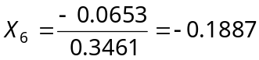 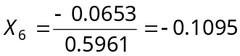

Chapter 9: Problem 3

With short sales allowed but no riskless lending or borrowing, the optimum portfolio depends on the investor’s utility function and will be found at a point along the upper half of the minimum-variance frontier of risky assets, which is the efficient frontier when riskless lending and borrowing do not exist. As is described in the text, the entire efficient frontier of risky assets can be delineated with various combinations of any two efficient portfolios on the frontier. One such efficient portfolio was found in Problem 2. By simply solving Problem 2 using a different value for R_{F} , another portfolio on the efficient frontier can be found and then the entire efficient frontier can be traced using combinations of those two efficient portfolios.

Chapter 9: Problem 4

In the table below, given that the riskless rate equals 5%, the securities are ranked in descending order by their excess return over standard deviation.

Security Rank i 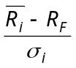 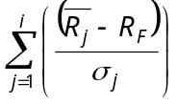 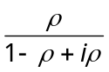 C_{i}

1 | 1 | 10 | 1.00 | 1.00 | 0.5000 | 0.5000
2 | 2 | 15 | 1.00 | 2.00 | 0.3333 | 0.6667
5 | 3 | 5 | 1.00 | 3.00 | 0.2500 | 0.7500
6 | 4 | 9 | 0.90 | 3.90 | 0.2000 | 0.7800
4 | 5 | 7 | 0.70 | 4.60 | 0.1667 | 0.7668
3 | 6 | 13 | 0.65 | 5.25 | 0.1429 | 0.7502
7 | 7 | 11 | 0.55 | 5.80 | 0.1250 | 0.7250

The numbers in the column above labeled C_{i} were obtained by recalling from the text that, if the constant-correlation model holds:

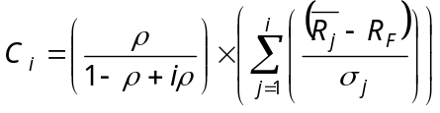

Thus, given that ρ = 0.5 for all pairs of securities:

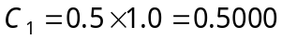

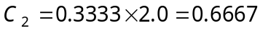
etc.

With no short sales, we only include those securities for which 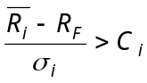. Thus, only securities 1, 2, 5 and 6 (the four highest ranked securities in the above table) are in the optimal (tangent) portfolio. We could have stopped our calculations after the first time we found a ranked security for which 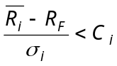, (in this case the fifth highest ranked security, security 4), but we did not so that we could demonstrate that for all of the remaining lower ranked securities as well.

Since security 6 (the fourth highest ranked security, where i = 4) is the last ranked security in descending order for which , we set C* = C₄ = 0.78 and solve for the optimum portfolio’s weights using the following formulas:

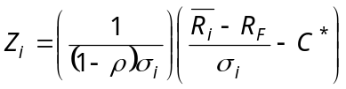

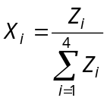
This gives us:
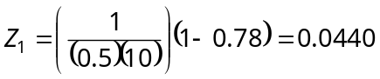

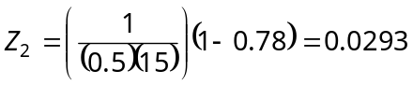

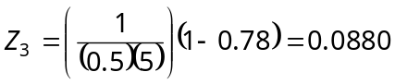

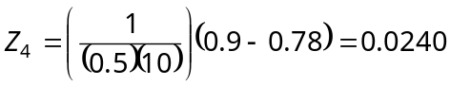

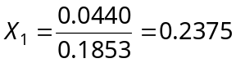

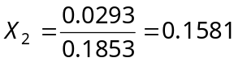

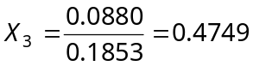

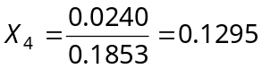

Since i = 1 for security 1, i = 2 for security 2, i = 3 for security 5 and i = 4 for security 6, the optimum (tangent) portfolio when short sales are not allowed consists of 23.75% invested in security 1, 15.81% % invested in security 2, 47.49% % invested in security 5 and 12.95% invested in security 6.

Chapter 9: Problem 5

This problem uses the same input data as Problem 4. When short sales are allowed, all securities are included and C* is equal to the value of C_{i} for the lowest ranked security. Referring back to the table given in the answer to Problem 4, we see that the lowest ranked security is security 7, where i = 7. Therefore, we have C* = C₇ = 0.725.

To solve for the optimum portfolio’s weights, we use the following formulas:

and
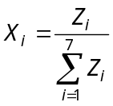 (for the standard definition of short sales)
or
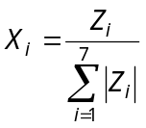 (for the Lintner definition of short sales)

So we have:
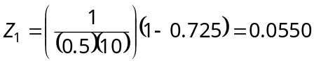
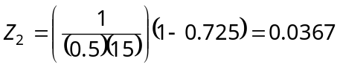
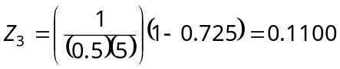
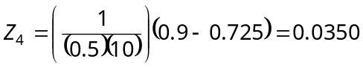
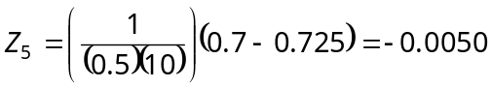
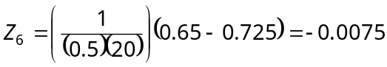
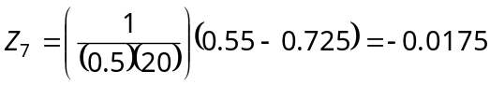

This gives us the following weights (by rank order) for the optimum portfolios under either the standard definition of short sales or the Lintner definition of short sales:

Standard Definition Lintner Definition

Security 1 (i = 1) 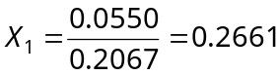 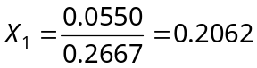

Security 2 (i = 2) 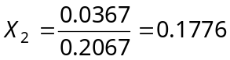 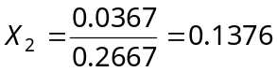

Security 5 (i = 3) 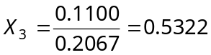 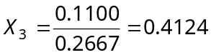

Security 6 (i = 4) 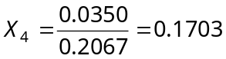 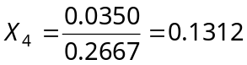

Security 4 (i = 5) 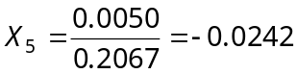 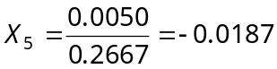

Security 3 (i = 6) 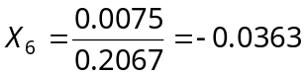 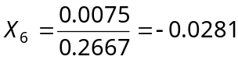

Security 7 (i = 7) 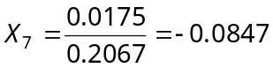 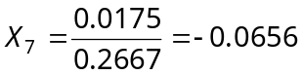

Chapter 9: Problem 6

With short sales allowed but no riskless lending or borrowing, the optimum portfolio depends on the investor’s utility function and will be found at a point along the upper half of the minimum-variance frontier of risky assets, which is the efficient frontier when riskless lending and borrowing do not exist. As is described in the text, the entire efficient frontier of risky assets can be delineated with various combinations of any two efficient portfolios on the frontier. One such efficient portfolio was found in Problem 5. By simply solving Problem 5 using a different value for R_{F} , another portfolio on the efficient frontier can be found and then the entire efficient frontier can be traced using combinations of those two efficient portfolios.

